Homework #4 — Support Vector Machines for Classification
Notebook Colab link
• https://drive.google.com/file/d/1Kiq69l2P7PpJZclmCRUBOnFwOqjDj1ZB/view?usp=sharing

I worked through the SVM notes in Colab section by section, in the same order as the handout: the maximum-margin idea on two separable blobs, kernel SVM on concentric rings, soft margins, and the Labeled Faces in the Wild (LFW) recognition example. After each section I changed one parameter and kept everything else fixed, so that any change in the result can be put down to that one parameter: the number of training points N, the RBF width gamma, the penalty C, and the number of PCA components in the face pipeline.
A few things in the handout code had to be adjusted to run on the current Colab stack (recent scikit-learn and matplotlib). The sklearn.datasets.samples_generator module no longer exists, so make_blobs and make_circles are imported from sklearn.datasets directly. The support-vector circles drawn with facecolors='none' came out invisible, because the edge colour now defaults to the face colour, so I added edgecolors='k'. The two interact() widgets only work in a live session, so I replaced each with a static panel over the same range. I also fixed random_state in make_circles; the handout leaves it free, which means the rings (and every number computed from them) change on each run.
Standard Imports
In [1]:
%matplotlib inline
import numpy as np
import matplotlib.pyplot as plt
from scipy import stats

# use seaborn plotting defaults
import seaborn as sns; sns.set()

Introduction
Two well separated Gaussian blobs, 50 points in total. This is the easy case the rest of the linear part builds on.
In [2]:
# sklearn.datasets.samples_generator was removed in newer scikit-learn,
# make_blobs is imported straight from sklearn.datasets now
from sklearn.datasets import make_blobs

X, y = make_blobs(n_samples=50, centers=2,
random_state=0, cluster_std=0.60)
plt.scatter(X[:, 0], X[:, 1], c=y, s=50, cmap='autumn');

Out:
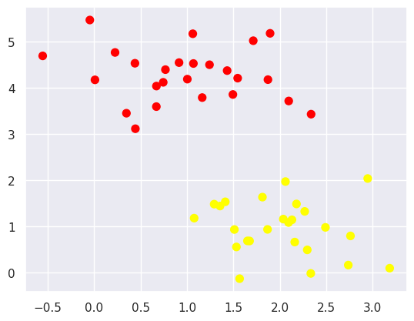

Three different lines all separate the training points perfectly, but they disagree on the new point marked with the red cross. Zero training error on its own does not pin down a unique classifier, and that is the gap the margin idea fills.
In [3]:
xfit = np.linspace(-1, 3.5)
plt.scatter(X[:, 0], X[:, 1], c=y, s=50, cmap='autumn')
plt.plot([0.6], [2.1], 'x', color='red', markeredgewidth=2, markersize=10)

for m, b in [(1, 0.65), (0.5, 1.6), (-0.2, 2.9)]:
plt.plot(xfit, m * xfit + b, '-k')

plt.xlim(-1, 3.5);

Out:
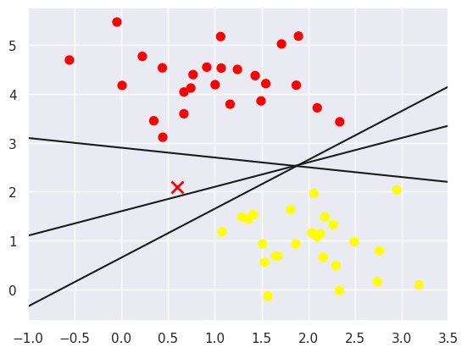

Maximizing the Margin with SVM
In [4]:
xfit = np.linspace(-1, 3.5)
plt.scatter(X[:, 0], X[:, 1], c=y, s=50, cmap='autumn')

for m, b, d in [(1, 0.65, 0.33), (0.5, 1.6, 0.55), (-0.2, 2.9, 0.2)]:
yfit = m * xfit + b
plt.plot(xfit, yfit, '-k')
plt.fill_between(xfit, yfit - d, yfit + d, edgecolor='none',
color='#AAAAAA', alpha=0.4)

plt.xlim(-1, 3.5);

Out:
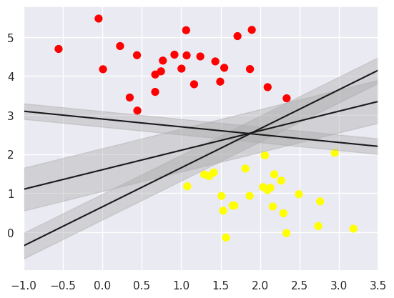

Drawing a band around each candidate line shows the difference between them: the middle line leaves the widest empty corridor. The SVM picks the line that makes this corridor as wide as possible.
Fitting a Support Vector Machine
A linear SVC with C = 1E10 is effectively a hard-margin SVM, since any point inside the margin is penalised so heavily that it cannot happen on separable data.
In [5]:
from sklearn.svm import SVC # "Support vector classifier"
model = SVC(kernel='linear', C=1E10)
model.fit(X, y)

Out:
SVC(C=10000000000.0, kernel='linear')

The printed model is shorter than in the handout because newer scikit-learn only shows the parameters that differ from their defaults; the model itself is the same.
In [6]:
def plot_svc_decision_function(model, ax=None, plot_support=True):
"""Plot the decision function for a 2D SVC"""
if ax is None:
ax = plt.gca()
xlim = ax.get_xlim()
ylim = ax.get_ylim()

# create grid to evaluate model
x = np.linspace(xlim[0], xlim[1], 30)
y = np.linspace(ylim[0], ylim[1], 30)
Y, X = np.meshgrid(y, x)
xy = np.vstack([X.ravel(), Y.ravel()]).T
P = model.decision_function(xy).reshape(X.shape)

# plot decision boundary and margins
ax.contour(X, Y, P, colors='k',
levels=[-1, 0, 1], alpha=0.5,
linestyles=['--', '-', '--'])

# plot support vectors
# edgecolors='k' added: with only facecolors='none' the circles come out invisible
# in the current matplotlib, so the support vectors were not showing at all
if plot_support:
ax.scatter(model.support_vectors_[:, 0],
model.support_vectors_[:, 1],
s=300, linewidth=1, facecolors='none', edgecolors='k');
ax.set_xlim(xlim)
ax.set_ylim(ylim)

In [7]:
plt.scatter(X[:, 0], X[:, 1], c=y, s=50, cmap='autumn')
plot_svc_decision_function(model);

Out:
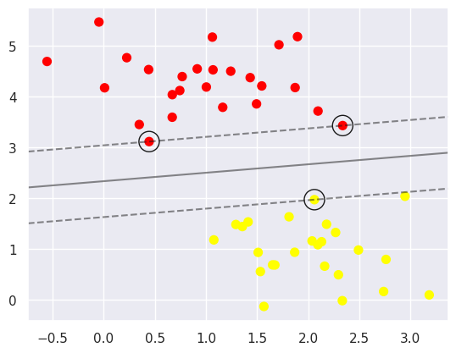

The solid line is the decision boundary (decision function = 0) and the dashed lines are the margins at ±1. Three training points sit exactly on the margins and are circled.
In [8]:
model.support_vectors_

Out:
array([[0.44359863, 3.11530945],
[2.33812285, 3.43116792],
[2.06156753, 1.96918596]])

These three support vectors agree with the values in the handout to all eight printed decimals, so the data set and the fit are reproduced exactly. Only these three points determine the boundary; the other 47 could be moved anywhere on the correct side of the margin without changing the model.
In [9]:
def plot_svm(N=10, ax=None):
X, y = make_blobs(n_samples=200, centers=2,
random_state=0, cluster_std=0.60)
X = X[:N]
y = y[:N]
model = SVC(kernel='linear', C=1E10)
model.fit(X, y)

ax = ax or plt.gca()
ax.scatter(X[:, 0], X[:, 1], c=y, s=50, cmap='autumn')
ax.set_xlim(-1, 4)
ax.set_ylim(-1, 6)
plot_svc_decision_function(model, ax)
return model # returned so the support vectors can be printed below

fig, ax = plt.subplots(1, 2, figsize=(16, 6))
fig.subplots_adjust(left=0.0625, right=0.95, wspace=0.1)
for axi, N in zip(ax, [60, 120]):
plot_svm(N, axi)
axi.set_title('N = {0}'.format(N))

Out:
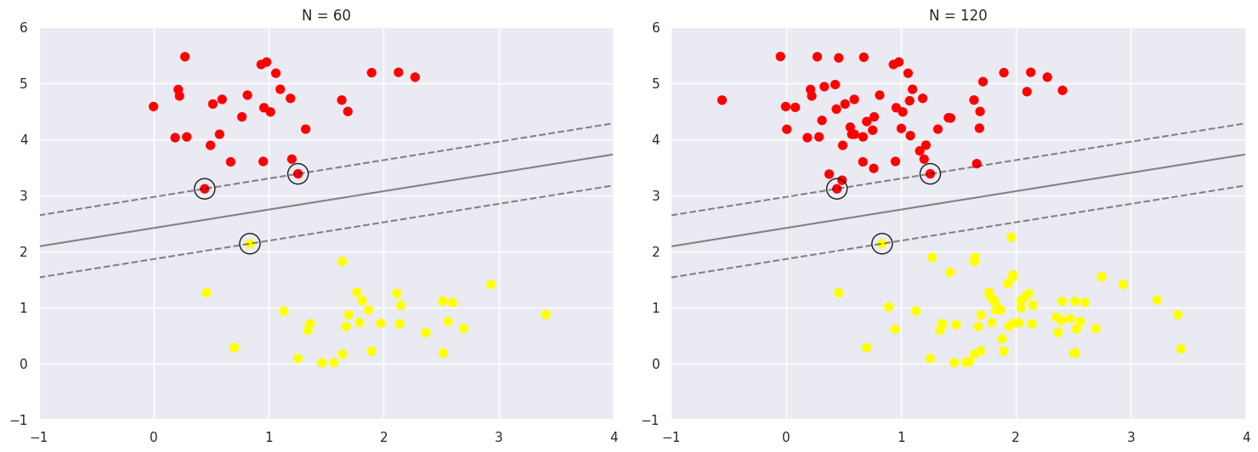

Parameter change 1: number of training points N
The handout checks this with an interact() slider between N = 10 and N = 200. I plotted N = 10, 60, 120 and 200 next to each other and printed the support vectors each time.
In [10]:
fig, ax = plt.subplots(1, 4, figsize=(22, 5.5))
models = {}
for axi, N in zip(ax, [10, 60, 120, 200]):
m = models[N] = plot_svm(N, axi)
axi.set_title('N = {0}'.format(N))
print('N = %3d margin width %.3f support vectors:' % (N, 2 /
np.linalg.norm(m.coef_[0])),
np.round(m.support_vectors_, 3).tolist())

# how many of the extra points 121-200 fall inside the margin of the N = 120 model?
Xall, yall = make_blobs(n_samples=200, centers=2, random_state=0, cluster_std=0.60)
f = models[120].decision_function(Xall[120:])
print('\npoints 121-200 inside the N = 120 margin:', np.sum(np.abs(f) < 1))

Out:
N = 10 margin width 2.422 support vectors: [[0.444, 3.115], [1.816, 1.12]]
N = 60 margin width 1.053 support vectors: [[0.444, 3.115], [1.256, 3.382], [0.837, 2.136]]
N = 120 margin width 1.053 support vectors: [[0.444, 3.115], [1.256, 3.382], [0.837, 2.136]]
N = 200 margin width 0.869 support vectors: [[0.59, 2.97], [2.338, 3.431], [0.837, 2.136]]

points 121-200 inside the N = 120 margin: 4
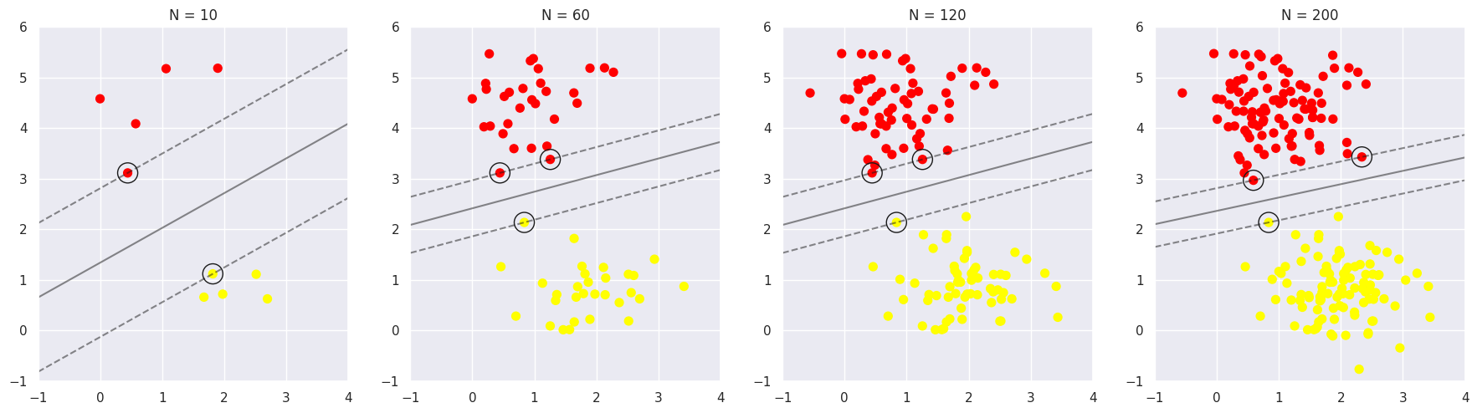

With N = 10 there are only two support vectors, one per class, and the margin is wide simply because the region between the classes has hardly been sampled. From N = 60 to N = 120 the model does not move at all: the same three support vectors, (0.444, 3.115), (1.256, 3.382) and (0.837, 2.136), give the same boundary and the same margin width of 1.053. This is the insensitivity to distant points the notes describe. At N = 200, however, two of the three support vectors are replaced (by (0.590, 2.970) and (2.338, 3.431)) and the margin shrinks to 0.869. The last line of the output explains why: 4 of the extra points 121 to 200 fall inside the margin of the N = 120 model, so that solution is no longer a valid hard-margin fit. The statement in the notes should be read with that condition in mind: extra data leaves the SVM unchanged only as long as none of it falls inside the current margin.
Beyond linear boundaries: Kernel SVM
Two concentric rings of 50 points each. A linear SVC is fitted first to show that it cannot work here.
In [11]:
from sklearn.datasets import make_circles
# random_state added so the same rings come out every run (the notes leave it random)
X, y = make_circles(100, factor=.1, noise=.1, random_state=0)

clf = SVC(kernel='linear').fit(X, y)

plt.scatter(X[:, 0], X[:, 1], c=y, s=50, cmap='autumn')
plot_svc_decision_function(clf, plot_support=False);

Out:
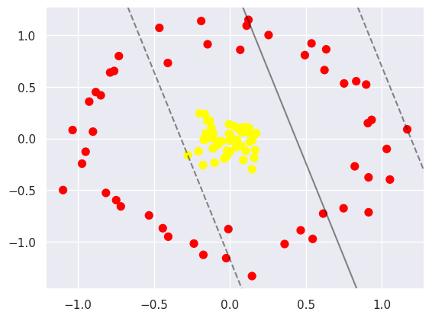

The linear boundary cuts through both rings; no straight line can put the inner ring on one side and the outer ring on the other.
In [12]:
r = np.exp(-(X ** 2).sum(1))

# where does each ring end up along the new r axis?
for c in (0, 1):
print('class %d : r from %.3f to %.3f' % (c, r[y == c].min(), r[y == c].max()))

Out:
class 0 : r from 0.165 to 0.495
class 1 : r from 0.896 to 1.000

The radial feature r = exp(−|x|²) maps the outer ring to r between 0.165 and 0.495 and the inner ring to r between 0.896 and 1.000. Any horizontal plane in the gap between about 0.5 and 0.9 separates the classes, so the plane at r = 0.7 suggested in the notes sits comfortably inside it.
In [13]:
from mpl_toolkits import mplot3d

def plot_3D(elev=30, azim=30, X=X, y=y, ax=None):
ax = ax or plt.subplot(projection='3d')
ax.scatter3D(X[:, 0], X[:, 1], r, c=y, s=50, cmap='autumn')
ax.view_init(elev=elev, azim=azim)
ax.set_xlabel('x')
ax.set_ylabel('y')
ax.set_zlabel('r')

# the notes rotate this with interact(); here two fixed views instead,
# the second one looks at the data from the side so the gap in r is visible
fig = plt.figure(figsize=(14, 6))
for k, (elev, azim) in enumerate([(30, 30), (0, 30)]):
axk = fig.add_subplot(1, 2, k + 1, projection='3d')
plot_3D(elev, azim, X, y, ax=axk)
axk.set_title('elev = %d, azim = %d' % (elev, azim))

Out:
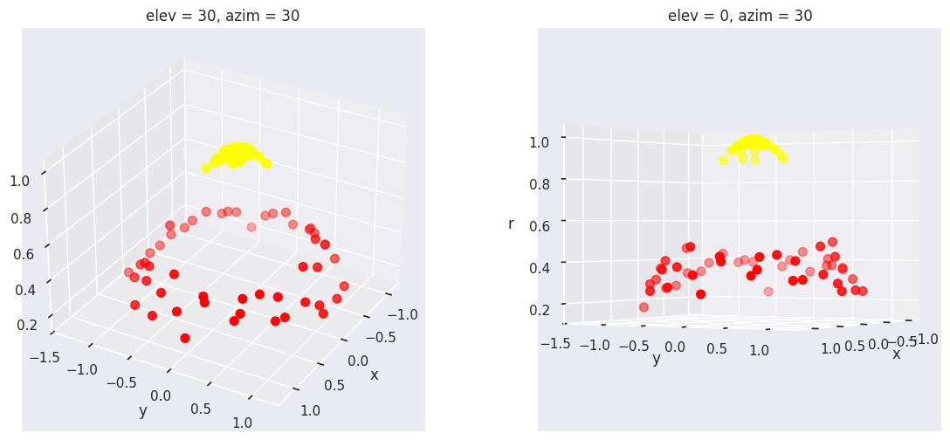

The side view on the right shows this gap directly. (As a side note, the interact call in the handout passes azip instead of azim. plot_3D has no azip argument, so the widget cannot call it; fixed views avoid the problem.)
In [14]:
clf = SVC(kernel='rbf', C=1E6)
clf.fit(X, y)

Out:
SVC(C=1000000.0)

With kernel='rbf' the SVM does this lifting implicitly. The gamma parameter is not given, so scikit-learn uses its current default gamma='scale', which is 1/(n_features · Var(X)) = 1.84 for this data. The handout output shows gamma='auto' (1/n_features = 0.5), which was the default in older versions.
In [15]:
plt.scatter(X[:, 0], X[:, 1], c=y, s=50, cmap='autumn')
plot_svc_decision_function(clf)
plt.scatter(clf.support_vectors_[:, 0], clf.support_vectors_[:, 1],
s=300, lw=1, facecolors='none', edgecolors='k');

Out:
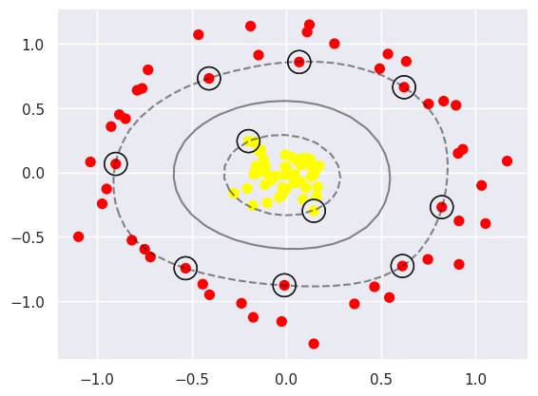

The RBF boundary is close to a circle between the two rings, and only a handful of points on the inner edge of the outer ring and the outer edge of the inner ring are support vectors.
Parameter change 2: RBF kernel width gamma
gamma sets how quickly the kernel similarity exp(−gamma·|x − x′|²) decays with distance, i.e. how local each support vector's influence is. I kept the same rings and C = 1E6, swept gamma from 0.1 to 100, and scored every model on 500 new points drawn from the same distribution (random_state = 1) that the model never saw.
In [16]:
X_new, y_new = make_circles(500, factor=.1, noise=.1, random_state=1) # unseen test rings

print('default gamma used above (gamma="scale") = %.2f' % (1 / (X.shape[1] * X.var())))
lin = SVC(kernel='linear').fit(X, y)
print('linear kernel : train acc %.2f test acc %.3f' % (lin.score(X, y), lin.score(X_new,
y_new)))
print()

fig, ax = plt.subplots(1, 4, figsize=(22, 5.5))
for axi, g in zip(ax, [0.1, 1, 10, 100]):
m = SVC(kernel='rbf', C=1E6, gamma=g).fit(X, y)
axi.scatter(X[:, 0], X[:, 1], c=y, s=50, cmap='autumn')
plot_svc_decision_function(m, axi)
axi.set_title('gamma = {0}'.format(g), size=14)
print('gamma = %-5g : train acc %.2f test acc %.3f support vectors %d of 100'
% (g, m.score(X, y), m.score(X_new, y_new), m.n_support_.sum()))

Out:
default gamma used above (gamma="scale") = 1.84
linear kernel : train acc 0.68 test acc 0.680

gamma = 0.1 : train acc 1.00 test acc 1.000 support vectors 6 of 100
gamma = 1 : train acc 1.00 test acc 1.000 support vectors 9 of 100
gamma = 10 : train acc 1.00 test acc 1.000 support vectors 40 of 100
gamma = 100 : train acc 1.00 test acc 0.974 support vectors 74 of 100
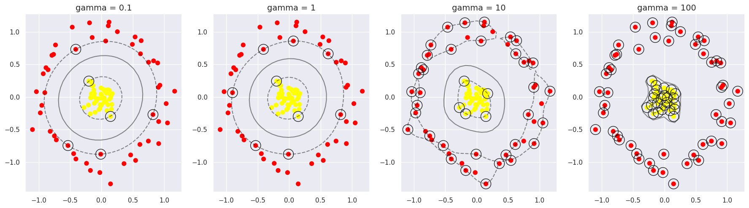

The linear kernel gets 68 % on both sets, only 18 percentage points above chance for two balanced classes. All four RBF models classify the training rings perfectly, so training accuracy says nothing about which one to trust. The number of support vectors does: it climbs from 6 at gamma = 0.1 to 9, 40 and finally 74 of the 100 training points at gamma = 100. At that point the kernel is so narrow that almost every point needs its own support vector, and the boundary shrink-wraps the inner ring, as the last panel shows. This is the one case where the test accuracy drops, to 97.4 %. The drop is small only because the two rings are far apart in this toy problem; on data with any real overlap the same over-flexible boundary would cost much more. For this data gamma between 0.1 and 1 gives the simplest model with perfect test accuracy, and the default of 1.84 used above is in the same regime, judging by its boundary.
Tuning the SVM: Softening Margins
In [17]:
X, y = make_blobs(n_samples=100, centers=2,
random_state=0, cluster_std=1.2)
plt.scatter(X[:, 0], X[:, 1], c=y, s=50, cmap='autumn');

Out:
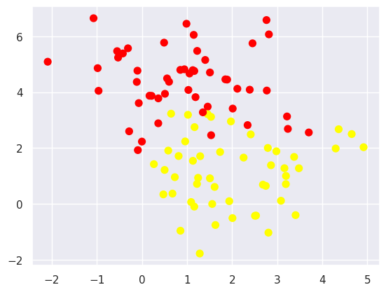

With cluster_std = 1.2 the two blobs overlap, so there is no perfect separating line and a hard margin is not an option.
In [18]:
X, y = make_blobs(n_samples=100, centers=2,
random_state=0, cluster_std=0.8)

fig, ax = plt.subplots(1, 2, figsize=(16, 6))
fig.subplots_adjust(left=0.0625, right=0.95, wspace=0.1)

for axi, C in zip(ax, [10.0, 0.1]):
model = SVC(kernel='linear', C=C).fit(X, y)
axi.scatter(X[:, 0], X[:, 1], c=y, s=50, cmap='autumn')
plot_svc_decision_function(model, axi)
axi.scatter(model.support_vectors_[:, 0],
model.support_vectors_[:, 1],
s=300, lw=1, facecolors='none', edgecolors='k');
axi.set_title('C = {0:.1f}'.format(C), size=14)

Out:
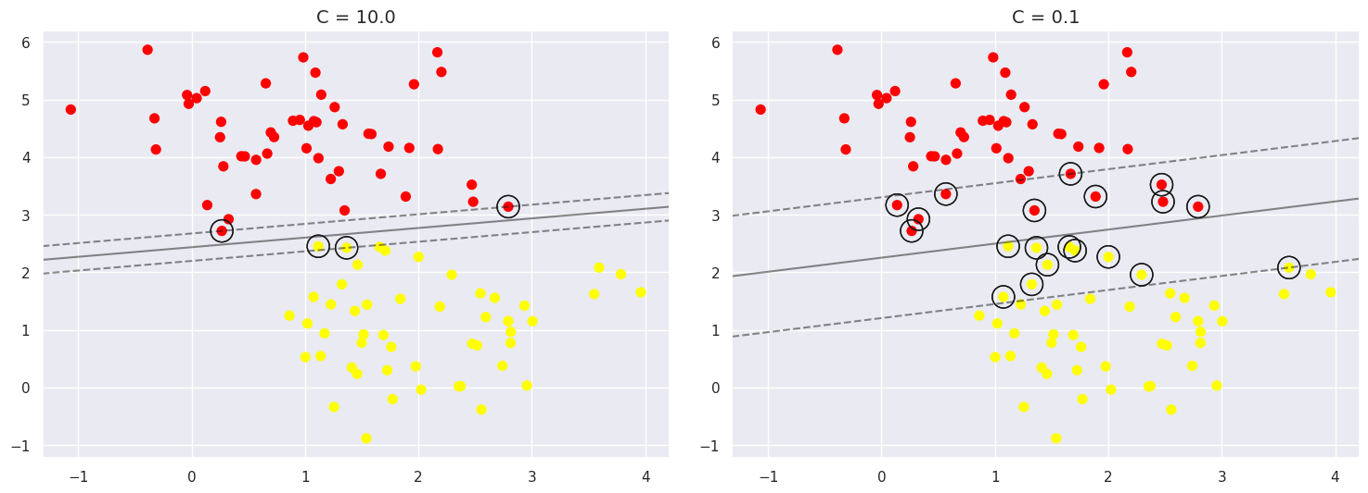

Using the less overlapping cluster_std = 0.8 data, C = 10 gives a narrow margin held by a few points, while C = 0.1 widens the margin and lets many points sit inside it.
Parameter change 3: penalty C
To see the trend rather than two end points, I swept C over four orders of magnitude on the same data and recorded the number of support vectors, the margin width 2/‖w‖ taken from coef_, and the training accuracy.
In [19]:
for C in [100, 10, 1, 0.1, 0.01]:
m = SVC(kernel='linear', C=C).fit(X, y)
w = m.coef_[0]
print('C = %-6g support vectors %3d margin width 2/|w| = %.3f train acc %.2f'
% (C, m.n_support_.sum(), 2 / np.linalg.norm(w), m.score(X, y)))

fig, ax = plt.subplots(1, 3, figsize=(20, 5.5))
for axi, C in zip(ax, [100, 1, 0.01]):
m = SVC(kernel='linear', C=C).fit(X, y)
axi.scatter(X[:, 0], X[:, 1], c=y, s=50, cmap='autumn')
plot_svc_decision_function(m, axi)
axi.set_title('C = {0}'.format(C), size=14)

Out:
C = 100 support vectors 3 margin width 2/|w| = 0.403 train acc 1.00
C = 10 support vectors 4 margin width 2/|w| = 0.470 train acc 1.00
C = 1 support vectors 9 margin width 2/|w| = 0.874 train acc 1.00
C = 0.1 support vectors 20 margin width 2/|w| = 2.038 train acc 1.00
C = 0.01 support vectors 52 margin width 2/|w| = 3.580 train acc 0.99
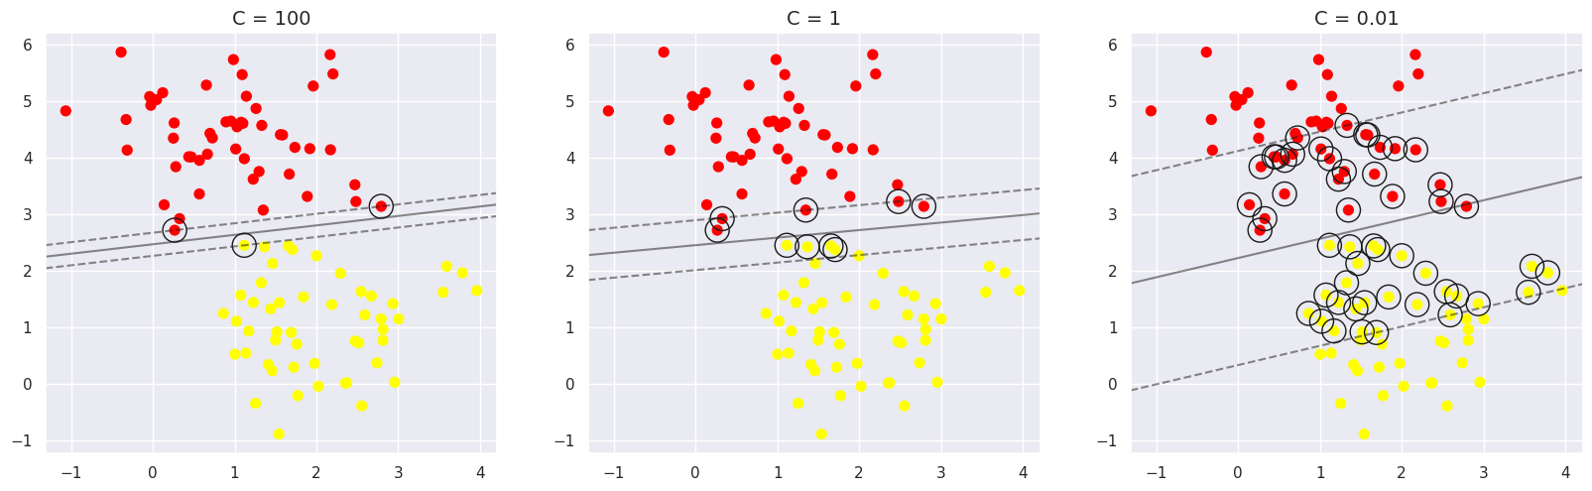

Going from C = 100 to C = 0.01 the margin widens almost ninefold, from 0.403 to 3.580, and the number of support vectors grows from 3 to 52, because every point that sits inside the margin or on its edge counts as a support vector. Training accuracy barely moves (100 % down to 99 %, one point misclassified at C = 0.01). C is the weight on the slack penalty, so a small C makes margin violations cheap and the optimiser trades them for a wider margin. The last panel shows how far this goes: at C = 0.01 more than half of the points are support vectors, i.e. they lie on or inside the margin. A wide, soft margin is usually the more robust choice when the data are noisy, but since the training accuracy is nearly flat across the whole range, training accuracy cannot be used to choose C. That has to be done with cross-validation, which is what the face example does next.
Example: Face Recognition
In [20]:
from sklearn.datasets import fetch_lfw_people
faces = fetch_lfw_people(min_faces_per_person=60)
print(faces.target_names)
print(faces.images.shape)
print(np.bincount(faces.target)) # images per person, same order as the names

Out:
['Ariel Sharon' 'Colin Powell' 'Donald Rumsfeld' 'George W Bush'
'Gerhard Schroeder' 'Hugo Chavez' 'Junichiro Koizumi' 'Tony Blair']
(1348, 62, 47)
[ 77 236 121 530 109 71 60 144]

The download gives 1,348 grayscale images of 62 × 47 pixels for the eight people with at least 60 photos each, the same set as in the handout. The last line gives the images per person, and the classes are quite unbalanced: George W. Bush has 530 images, Junichiro Koizumi 60.
In [21]:
# figsize enlarged (the default one made the long names run into each other)
fig, ax = plt.subplots(3, 5, figsize=(12, 8))
for i, axi in enumerate(ax.flat):
axi.imshow(faces.images[i], cmap='bone')
axi.set(xticks=[], yticks=[])
axi.set_xlabel(faces.target_names[faces.target[i]], fontsize=11)
fig.tight_layout()

Out:
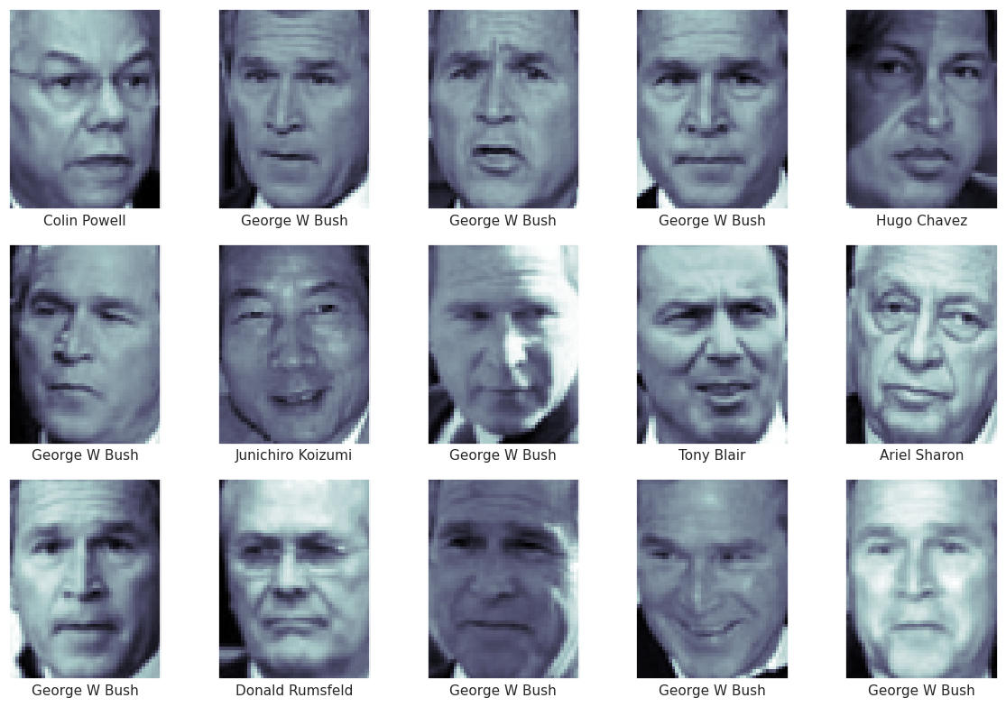

Each image is flattened into a 2,914-dimensional vector. PCA with whitening reduces this to 150 components before the RBF SVM, and class_weight='balanced' reweights the classes so that Bush does not dominate the fit. RandomizedPCA no longer exists, so PCA is imported under that name, as in the handout.
In [22]:
from sklearn.svm import SVC
#from sklearn.decomposition import RandomizedPCA # Old version
from sklearn.decomposition import PCA as RandomizedPCA
from sklearn.pipeline import make_pipeline

pca = RandomizedPCA(n_components=150, whiten=True, random_state=42)
svc = SVC(kernel='rbf', class_weight='balanced')
model = make_pipeline(pca, svc)

In [23]:
#from sklearn.cross_validation import train_test_split # Old version
from sklearn.model_selection import train_test_split
Xtrain, Xtest, ytrain, ytest = train_test_split(faces.data, faces.target,
random_state=42)
print('train', Xtrain.shape, ' test', Xtest.shape)

Out:
train (1011, 2914) test (337, 2914)

The default split keeps 25 % for testing: 1,011 training and 337 test images.
In [24]:
#from sklearn.grid_search import GridSearchCV #Old version
from sklearn.model_selection import GridSearchCV
param_grid = {'svc__C': [1, 5, 10, 50],
'svc__gamma': [0.0001, 0.0005, 0.001, 0.005]}
grid = GridSearchCV(model, param_grid)

%time grid.fit(Xtrain, ytrain)
print(grid.best_params_)

Out:
CPU times: user 1min 15s, sys: 800 ms, total: 1min 16s
Wall time: 39.5 s
{'svc__C': 5, 'svc__gamma': 0.001}

The grid search (5-fold cross-validation on the training set) takes about a minute and picks C = 5, gamma = 0.001. The handout reports C = 10 with the same gamma. To see whether that difference matters, I printed the mean CV accuracy of every grid cell.
In [25]:
# mean 5-fold CV accuracy for every cell of the grid (rows C, columns gamma)
import pandas as pd
cv = pd.DataFrame(grid.cv_results_)
print(cv.pivot(index='param_svc__C', columns='param_svc__gamma',
values='mean_test_score').round(3))
print('\nstd over the 5 folds at the best cell: %.3f' % cv.loc[grid.best_index_,
'std_test_score'])

Out:
param_svc__gamma 0.0001 0.0005 0.0010 0.0050
param_svc__C
1 0.229 0.635 0.821 0.822
5 0.703 0.826 0.829 0.817
10 0.811 0.817 0.818 0.817
50 0.811 0.805 0.803 0.815

std over the 5 folds at the best cell: 0.010

The surface is flat near the optimum: C = 5 scores 0.829, and C = 1, 5 and 10 at gamma = 0.001 are all within about 1 % of each other. That is about the same size as the fold-to-fold standard deviation at the best cell (0.010, last line of the output), so C = 5 and C = 10 are not clearly distinguishable on this data, and the difference from the handout is most likely version-dependent noise (e.g. in the randomized PCA) rather than a real disagreement. The best cell is not on the edge of the grid, so the grid does not need to be widened. The lower-left corner (C = 1, gamma = 0.0001) collapses to 0.229: with both a very soft margin and a very wide kernel the model underfits so badly that it does worse than simply calling every face Bush (about 0.39).
In [26]:
model = grid.best_estimator_
yfit = model.predict(Xtest)

In [27]:
fig, ax = plt.subplots(4, 6)
for i, axi in enumerate(ax.flat):
axi.imshow(Xtest[i].reshape(62, 47), cmap='bone')
axi.set(xticks=[], yticks=[])
axi.set_ylabel(faces.target_names[yfit[i]].split()[-1],
color='black' if yfit[i] == ytest[i] else 'red')
fig.suptitle('Predicted Names; Incorrect Labels in Red', size=14);

Out:
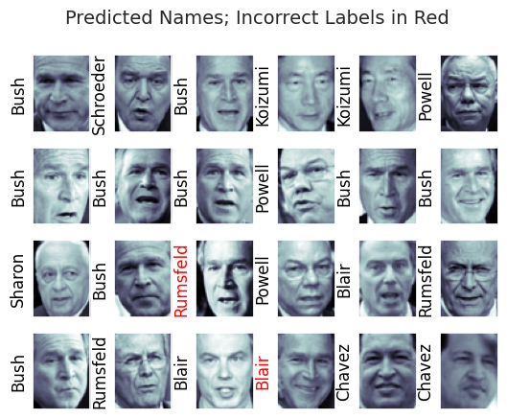

Two of the 24 test faces shown are mislabelled, both of them Bush (one predicted as Rumsfeld, one as Blair). The handout sample had one error.
In [28]:
from sklearn.metrics import classification_report
print(classification_report(ytest, yfit,
target_names=faces.target_names))

Out:
precision recall f1-score support

Ariel Sharon 0.65 0.87 0.74 15
Colin Powell 0.83 0.88 0.86 68
Donald Rumsfeld 0.70 0.84 0.76 31
George W Bush 0.97 0.80 0.88 126
Gerhard Schroeder 0.76 0.83 0.79 23
Hugo Chavez 0.93 0.70 0.80 20
Junichiro Koizumi 0.86 1.00 0.92 12
Tony Blair 0.82 0.98 0.89 42

accuracy 0.85 337
macro avg 0.82 0.86 0.83 337
weighted avg 0.86 0.85 0.85 337

Overall test accuracy is 0.85, the same as in the handout. The per-class numbers show the effect of class_weight='balanced' clearly: Bush has the highest precision, 0.97, but a recall of only 0.80, because the reweighting makes the model less willing to fall back on the largest class. The small classes get the opposite trade-off: Ariel Sharon has recall 0.87 with precision 0.65. The macro-averaged F1, which weights every person equally, is 0.83.
In [29]:
from sklearn.metrics import confusion_matrix
mat = confusion_matrix(ytest, yfit)
sns.heatmap(mat.T, square=True, annot=True, fmt='d', cbar=False,
xticklabels=faces.target_names,
yticklabels=faces.target_names)
plt.xlabel('true label')
plt.ylabel('predicted label');

Out:
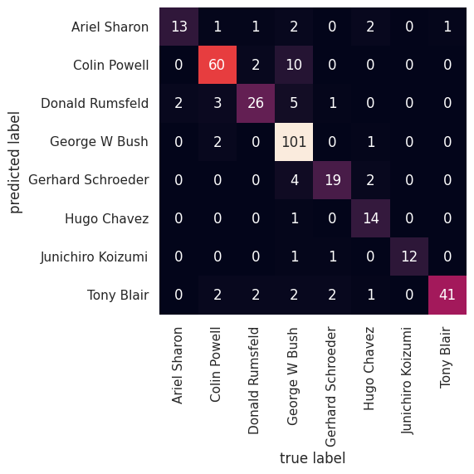

The confusion matrix (predicted label on the vertical axis) shows where Bush's recall goes. Of his 126 test images, 101 are correct and the largest single error is 10 images predicted as Colin Powell, followed by 5 as Rumsfeld and 4 as Schroeder. Koizumi, the smallest class, is classified perfectly (12 of 12).
Parameter change 4: number of PCA components
The handout fixes PCA at 150 components. I compared 30, 80, 150 and 250. One point about the design: because the components are whitened (every component scaled to unit variance), the typical squared distance between two faces grows roughly in proportion to the number of components. A gamma tuned at 150 components would therefore be wrong for the other settings, and the comparison would really be measuring that mismatch. So the whole grid search was re-run for each setting, on the same train/test split.
In [30]:
from sklearn.metrics import accuracy_score, f1_score

for n in [30, 80, 150, 250]:
pipe = make_pipeline(RandomizedPCA(n_components=n, whiten=True, random_state=42),
SVC(kernel='rbf', class_weight='balanced'))
g = GridSearchCV(pipe, param_grid, n_jobs=-1).fit(Xtrain, ytrain)
yp = g.predict(Xtest)
var = g.best_estimator_.named_steps['pca'].explained_variance_ratio_.sum()
print('components %3d | variance kept %.3f | best C %-3g gamma %-6g | CV acc %.3f | '
'test acc %.3f | macro F1 %.3f'
% (n, var, g.best_params_['svc__C'], g.best_params_['svc__gamma'],
g.best_score_, accuracy_score(ytest, yp), f1_score(ytest, yp,
average='macro')))

Out:
components 30 | variance kept 0.785 | best C 50 gamma 0.005 | CV acc 0.733 | test acc 0.742 | macro F1 0.686
components 80 | variance kept 0.889 | best C 1 gamma 0.005 | CV acc 0.827 | test acc 0.828 | macro F1 0.800
components 150 | variance kept 0.941 | best C 5 gamma 0.001 | CV acc 0.829 | test acc 0.849 | macro F1 0.831
components 250 | variance kept 0.971 | best C 5 gamma 0.001 | CV acc 0.799 | test acc 0.834 | macro F1 0.812

Accuracy rises steeply up to about 80 components (0.742 to 0.828 on the test set), peaks at 150 (0.849, macro F1 0.831), and then falls at 250 (0.834) even though the kept variance goes up from 94.1 % to 97.1 %. The drop is a side effect of whitening. Components beyond about 150 carry very little variance and are mostly pixel noise and lighting detail, but whitening stretches each of them to unit variance, so in the RBF distance they weigh as much as the leading components that encode face shape. More components therefore add noise dimensions to the kernel, not information. The selected gamma also moves in the expected direction, from 0.005 at 30 and 80 components to 0.001 at 150 and 250, which is consistent with the distance scaling above and confirms that re-tuning per setting was needed. The 150 used in the handout turned out to be the best of the four values I tried. The caveat is that each number comes from a single split of 337 test images, so a difference of about 1.5 %, e.g. 150 vs 250, is around five images and should not be over-read. The drop below 80 components, on the other hand, is far larger than that.
Summary
All of the handout code runs on the current Colab stack after the small changes listed at the start, and the reproducible parts agree with the handout: the three support vectors of the first model match to eight decimals, and the overall face-recognition accuracy is the same 0.85. The parameter studies all point to the same practical lesson: training accuracy is a poor guide for tuning an SVM. It stayed at or near 100 % while the number of support vectors went from 6 to 74 with gamma and from 3 to 52 with C. The number of support vectors, held-out accuracy, and cross-validation over a grid are what actually separate a good setting from a bad one. In the face pipeline the preprocessing mattered as much as the SVM hyper-parameters, and more PCA components were not better once whitening was involved.

